Project Development Phase
Model Performance Test

Date | 02 October, 2026
Team ID | SWTID-2026-3664
Project Name | Script-Controlled ACL – Restrict Record Access Based on Field Value
Maximum Marks

Model Performance Testing:
Project team shall fill the following information in model performance testing template.
S.No. | Parameter | Values | Screenshot
 | Model Summary | ServiceNow Script-Controlled ACL using user roles and record field values. | 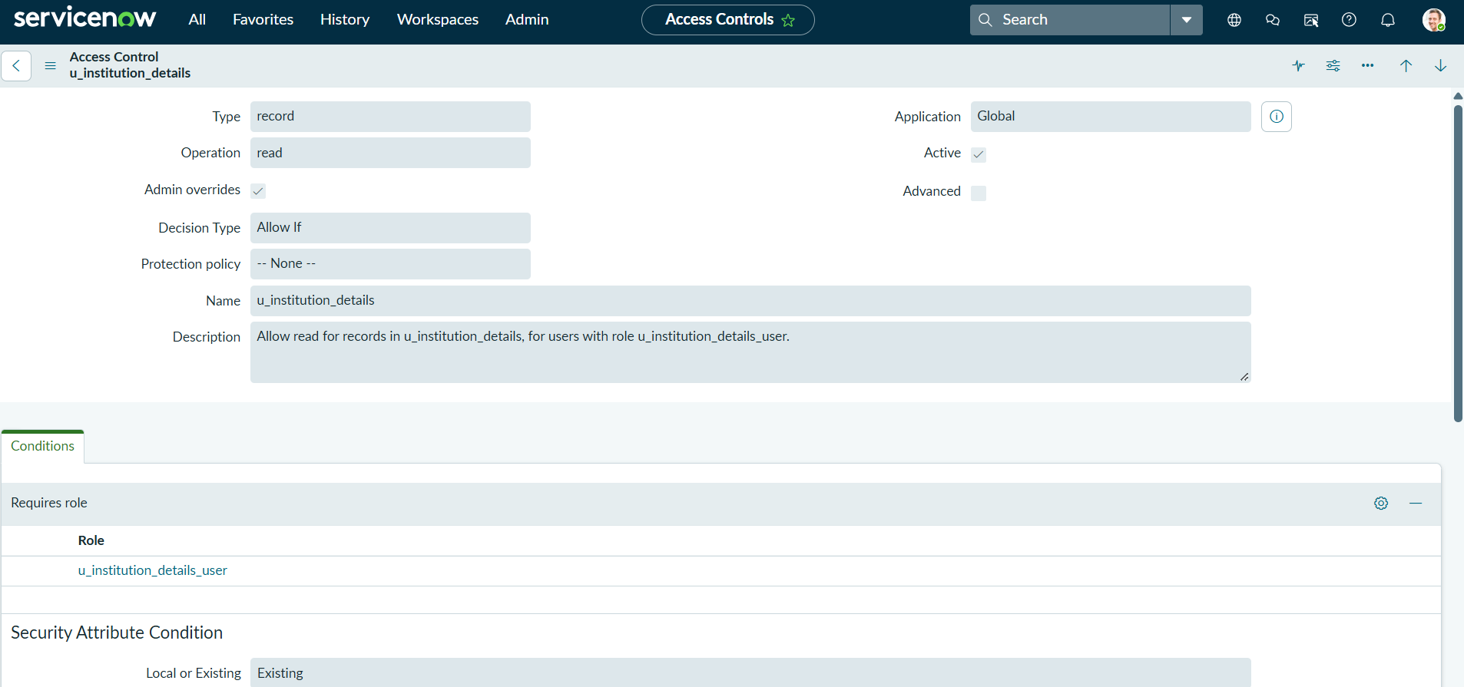
 | Accuracy | Access control worked as defined; unauthorized users were denied access to restricted records. | 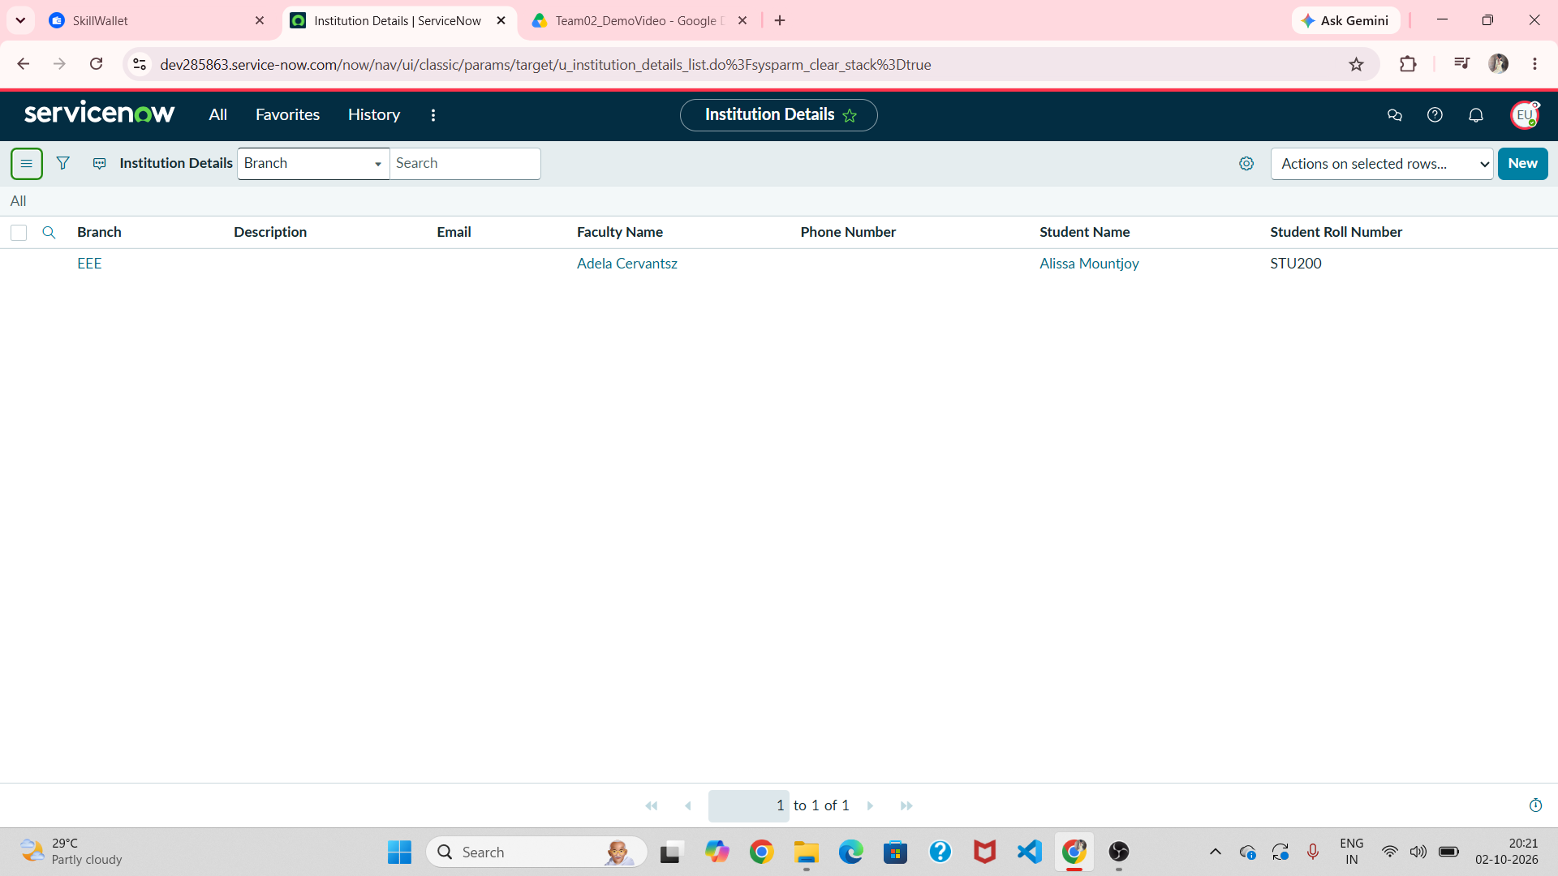
3. | Fine Tunning Result( if Done) | ACL conditions were tested and refined for READ, CREATE, WRITE and DELETE operations. | 